Calculus 3 Lecture 12.3/12.5: TNB (Frenet-Serret) Frames, Curvature, Torsion, Encapsulation

TNB Frames describe how a particle on a space curve (Vector function) is heading (), Turning (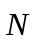) and twisting ()

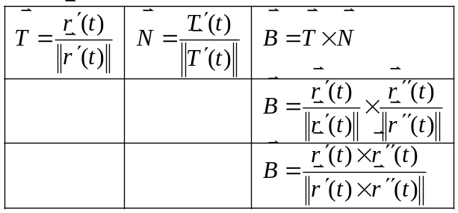

Curvature: A measure of a curve: failure to be a line.
The more curves in a function, the larger the curvature.
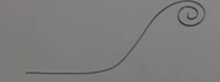
Curvature is a relationship between arc-length and the tangent vector
Arc-length compared to the tangent vector (heading)

How is changing with respect to arc-length

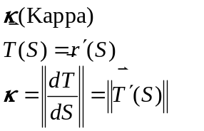

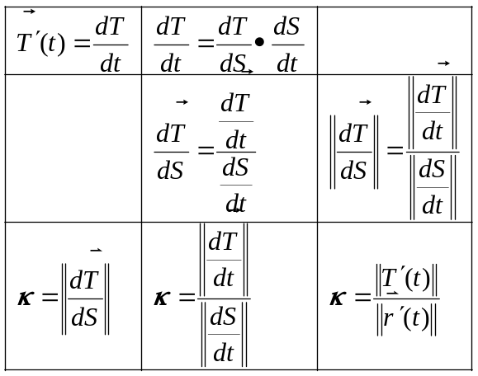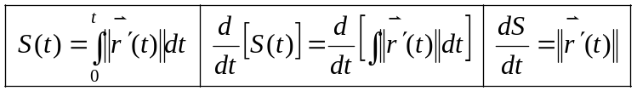
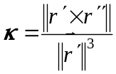 curvature for polynomials ONLY
Torsion: Tau
A measure of a curves failure to be contained in a plane.

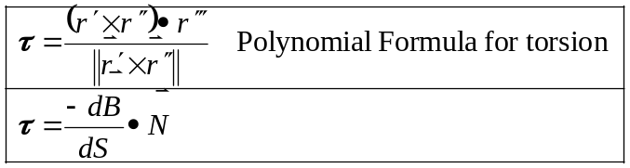

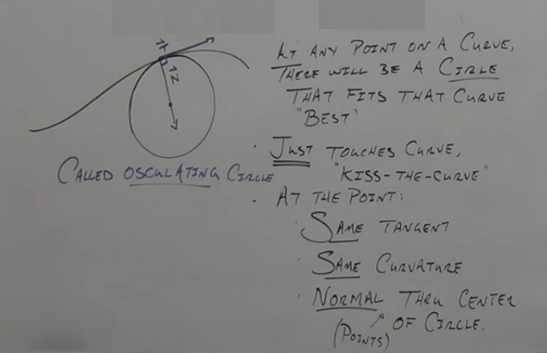
The plane that contains the circle is called the osculating plane (must contain 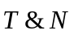)
is the normal to the osculating plane.

The radius of the osculating circle is called the “radius of curvature” 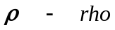
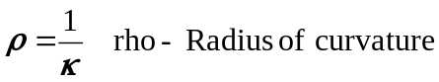

The Plane that contains 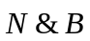 is called the normal plane and contains all vectors orthogonal to ( is normal)

Example
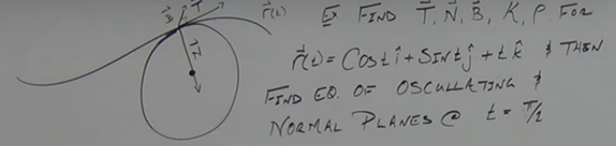
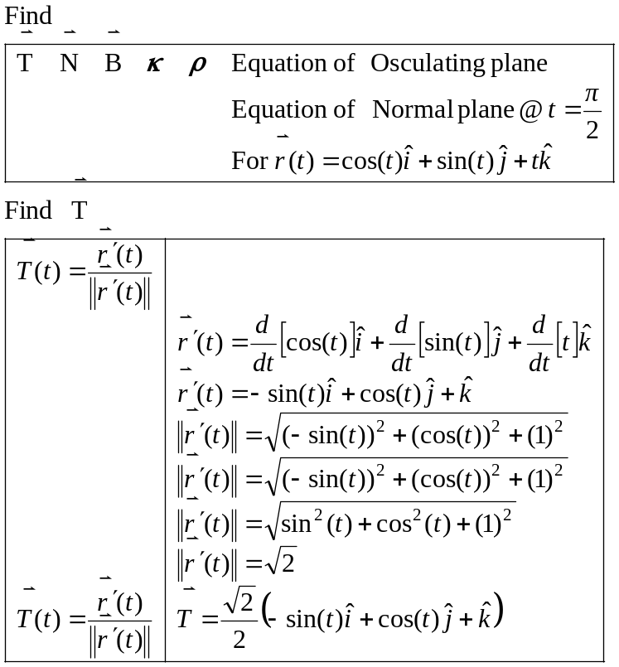

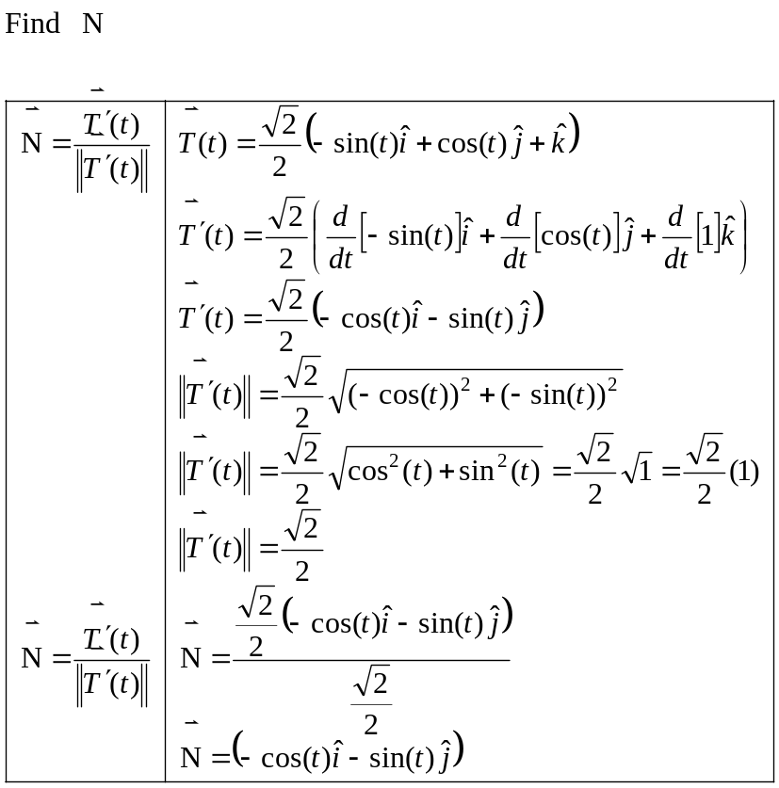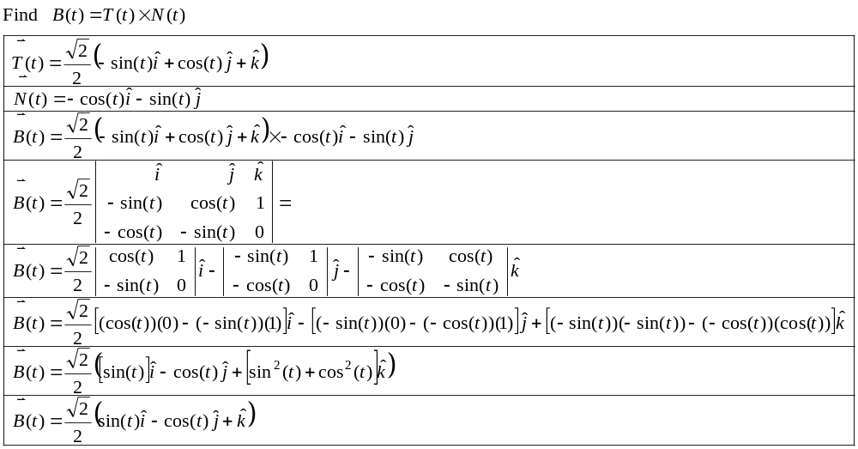
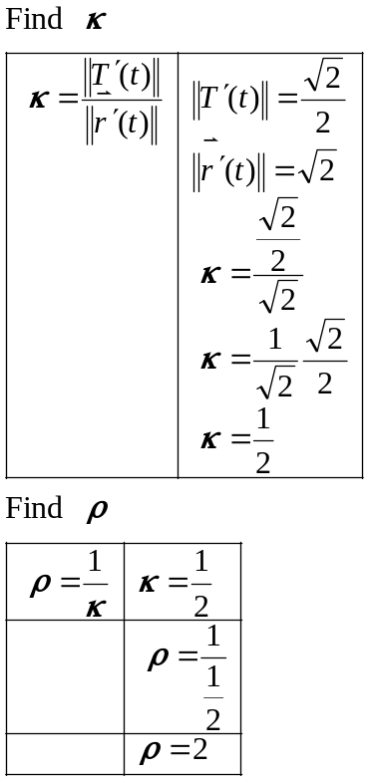

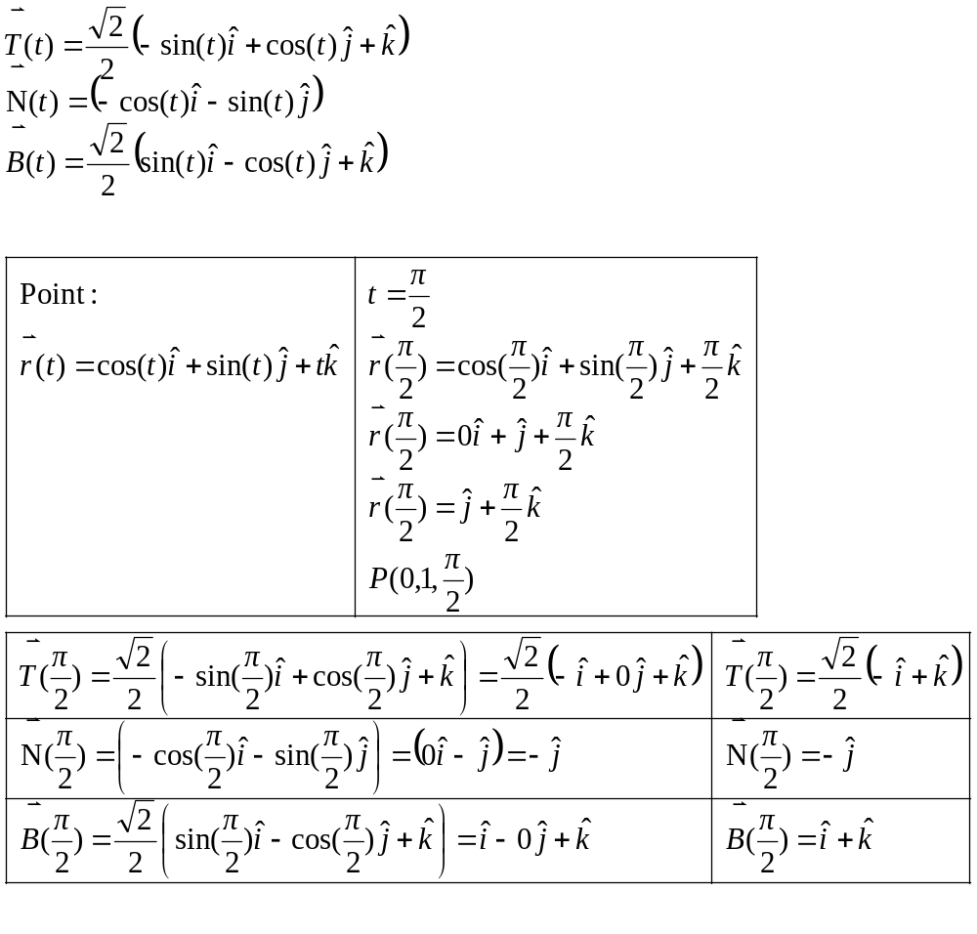

Osculating plane:
The plane that contains the circle is called the osculating plane (must contain )
is the normal to the osculating plane.

Need point and normal vector
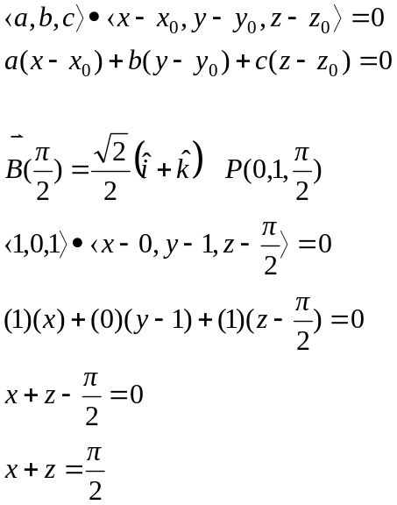

Normal plane:
The Plane that contains is called the normal plane and contains all vectors orthogonal to ( is normal)

Need point and normal vector
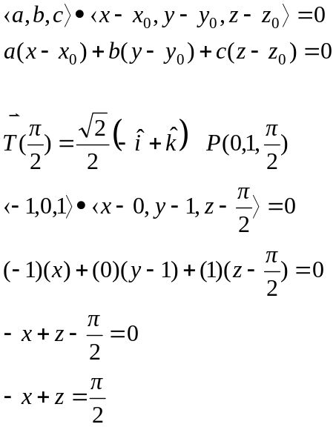
Example
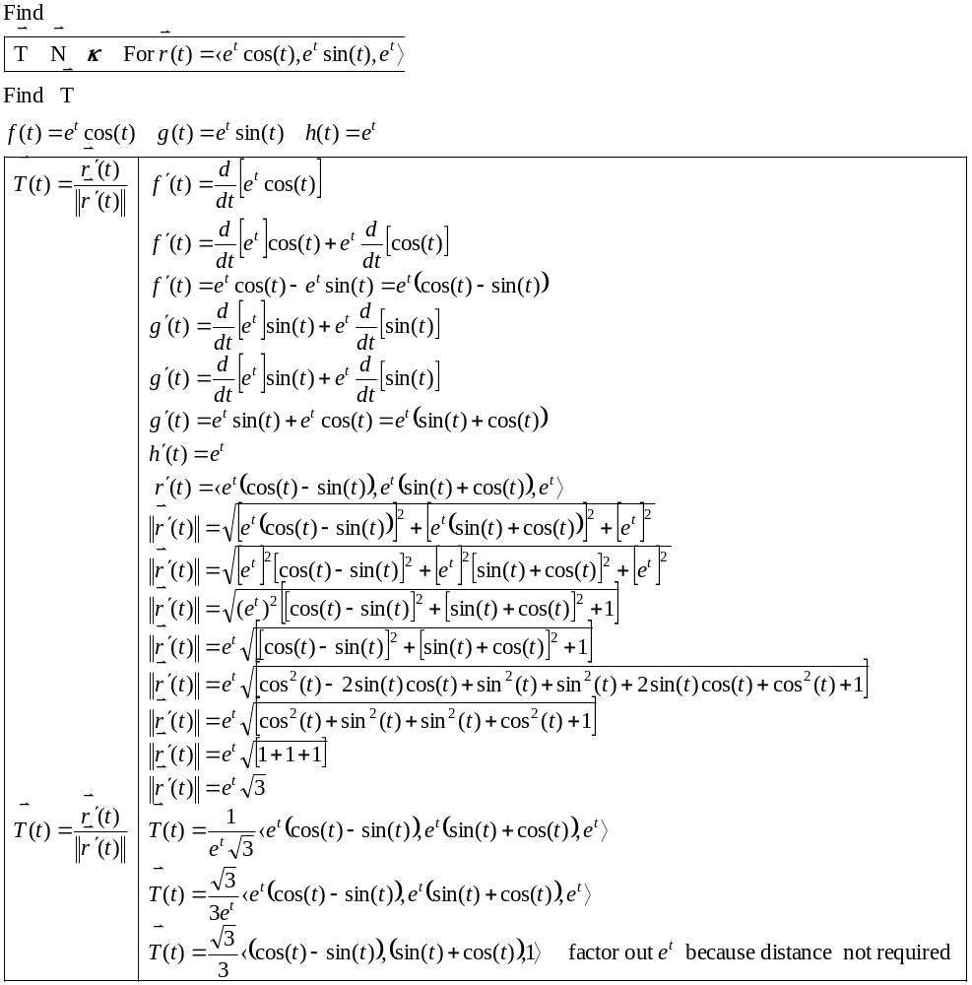
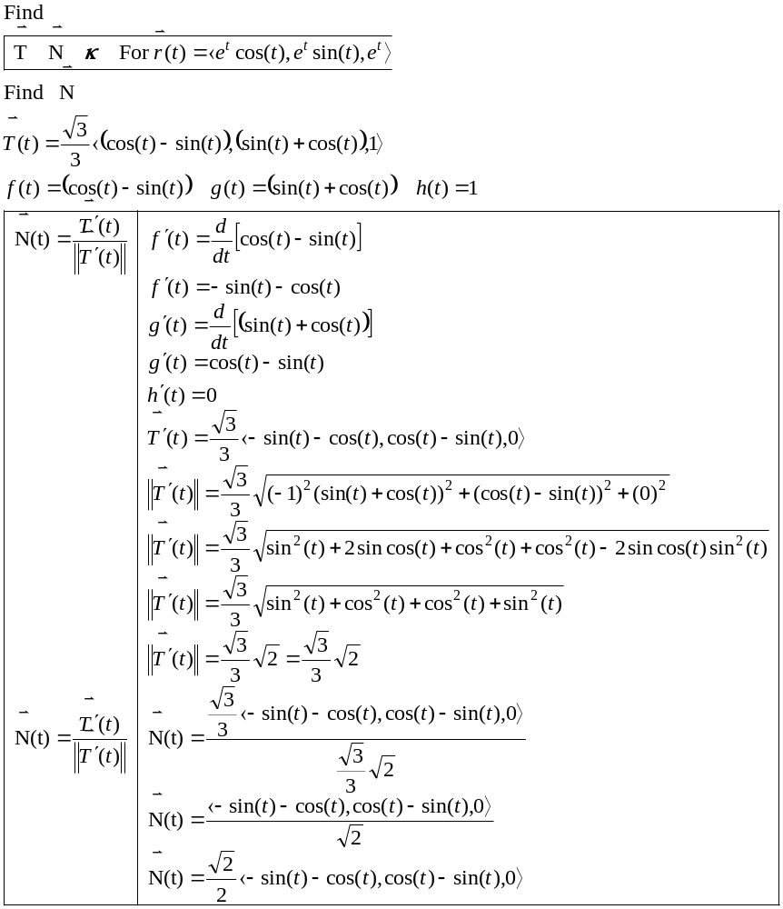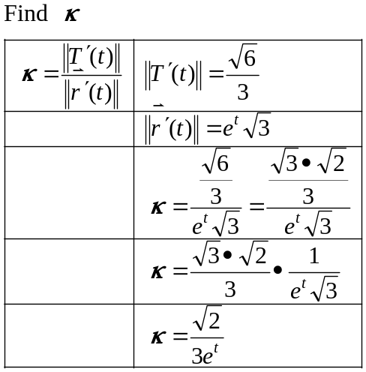

Example
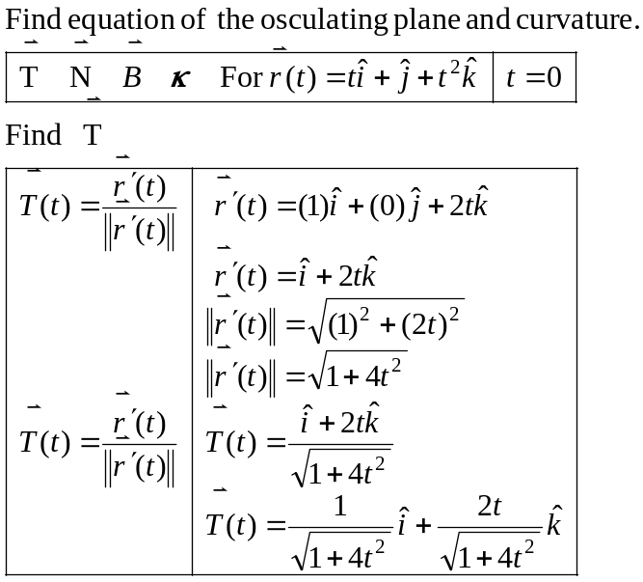
Cannot separate any scalars (Magnitude ) when they have the variable “t” in them. Must distribute Magnitude into the components of x,y,z….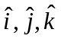…

Otherwise nasty product and quotient rules for derivatives. NOOOOO

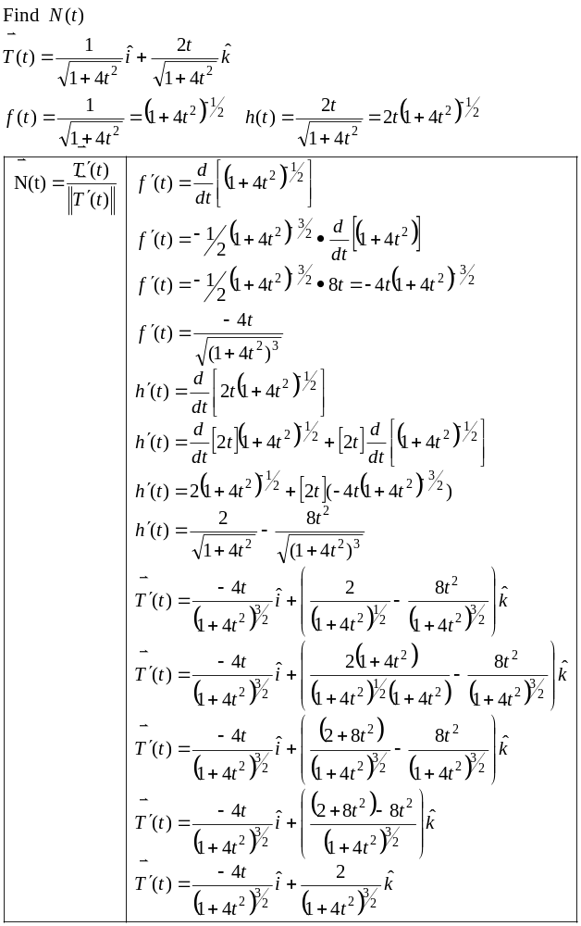

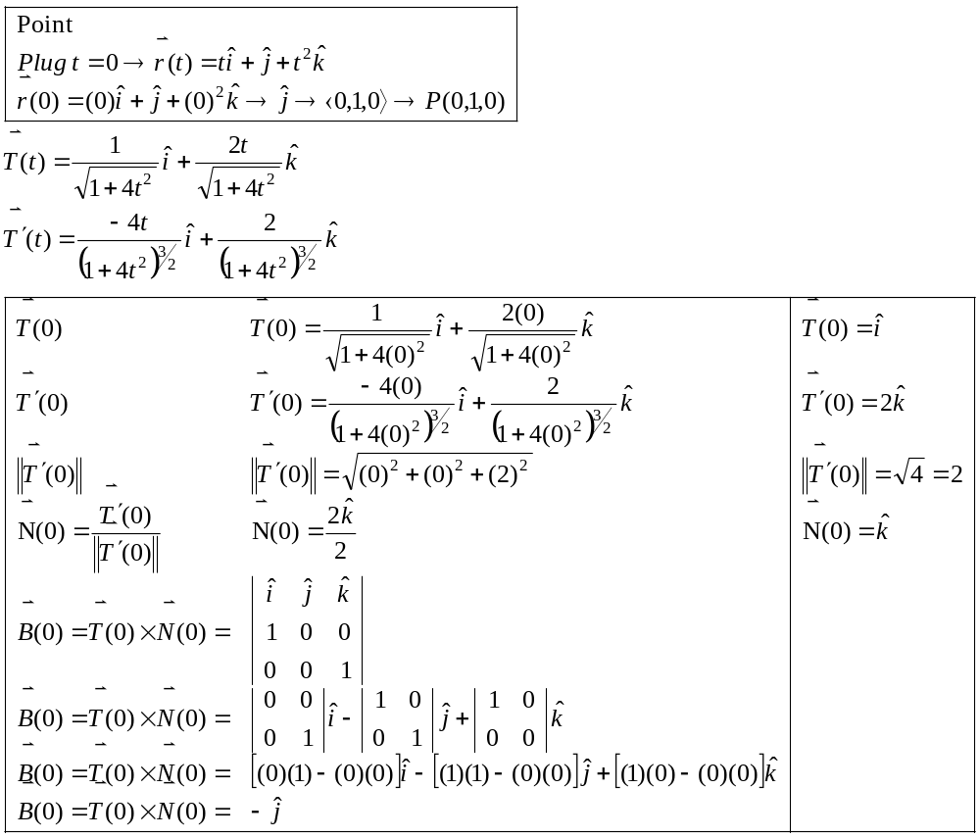

Osculating plane:
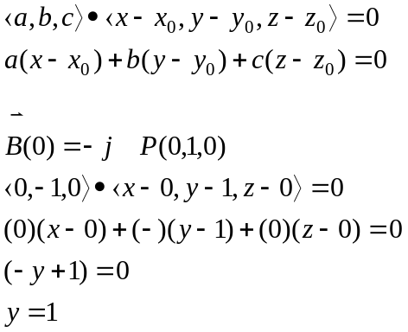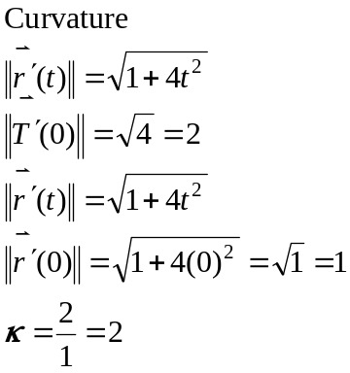
IF you only need curvature and you have a polynomial.
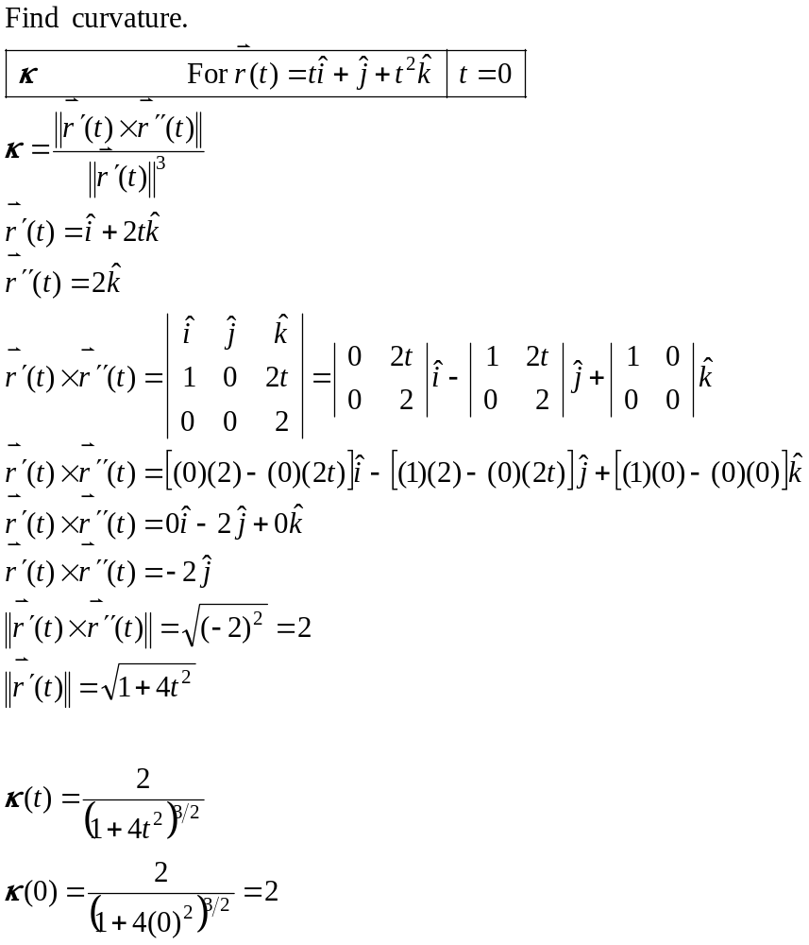
Vector Encapsulation
Example
